Project emblem: game play mechanics

Players can move units they have selected in addition it will show the units attack range.

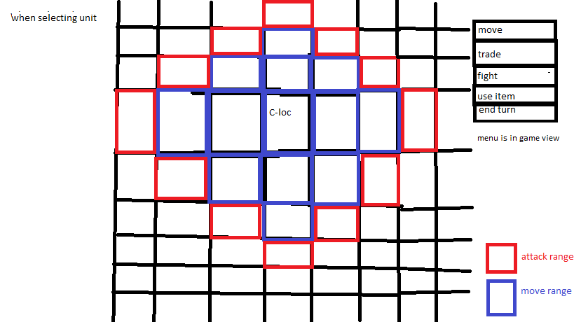

In addition, units can trade items if they are adjacent to each other unless stated other wise from a skill or outside source.

Units can use items in their inventory this can range from useable items like healing potions and fire bombs or change their currently equipped weapon.

There will also be skills that impact the terrain or multiply how the unit does damage or hampers it.

So possibly something like.

Utility skills, skills that don’t have combat applications.

Heavy foot steps: terrain this unit lands on into a plain’s terrain square when equipped.

Serene heart: heals 10% hp if unit is on a forest terrain when equipped.

Combat skills

Heavy blow: this unit deals +2 damage but has 5 less accuracy when equipped.

Arachne assault: deals +5 damage to Arachne type enemies.

Defense skills.

Slime body: this unit takes -2 damage but has -1 movement range when equipped.

Group mentality: -3 damage taken if there is an ally next to this unit when equipped.

-elemental items/attacks effect terrain

Fire based attack

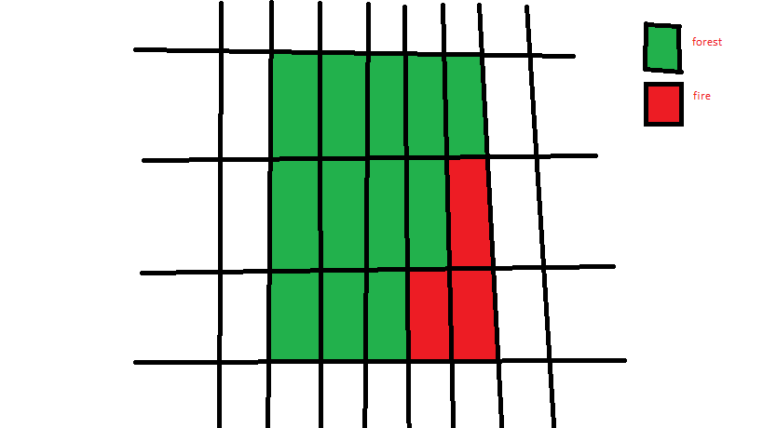

The fire can spread damaging all those in the area and clearing it, acid attacks can work in the same way (destroy terrain) but does not spread.

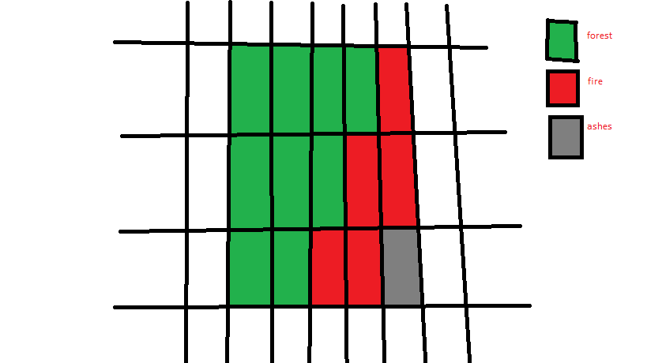

Ice

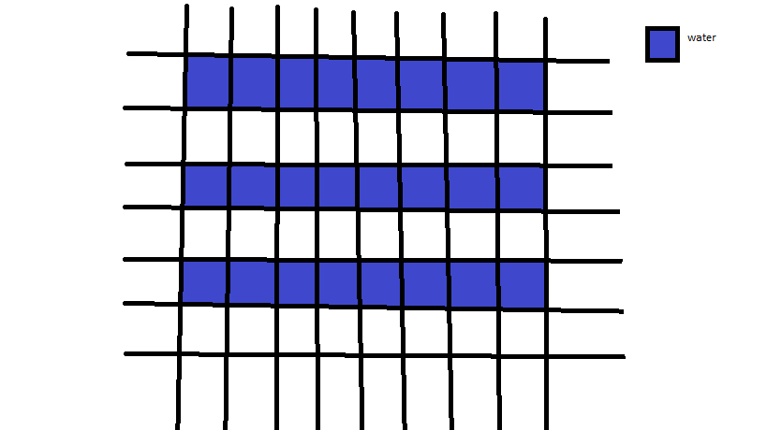

Ice can freeze water to create bridges for units to walk over, it can also be melted by fire or laser-based attacks.

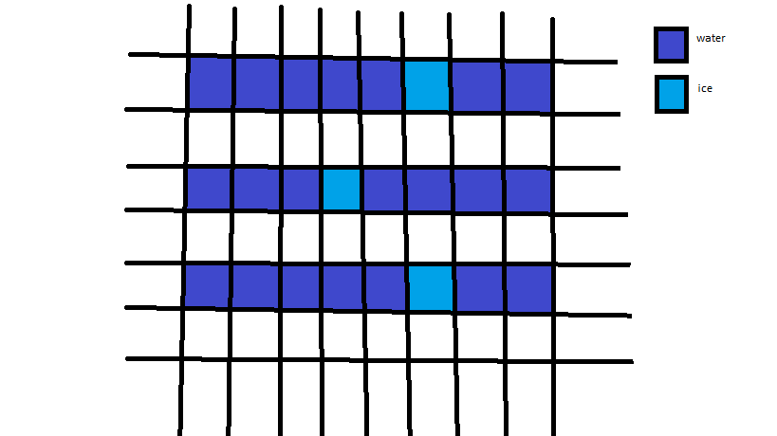

electric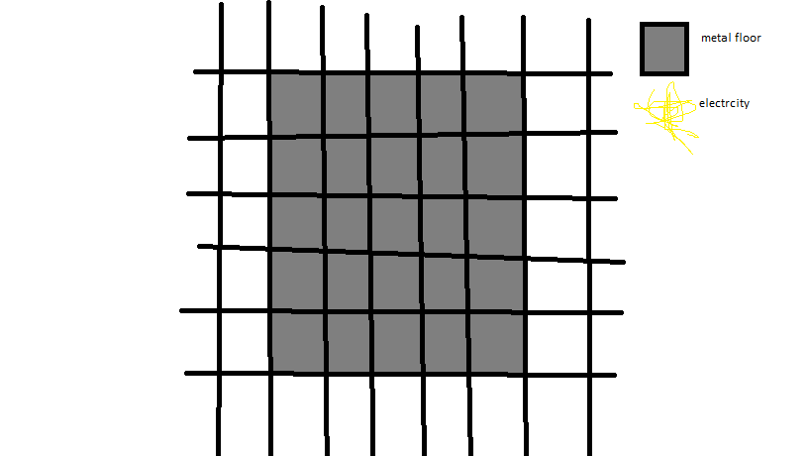

electric based attacks have their range extended if used on an metal floor and will cause it be electrified for a few turns damaging units standing on it.

maybe able to destroy cracked walls if implemented.

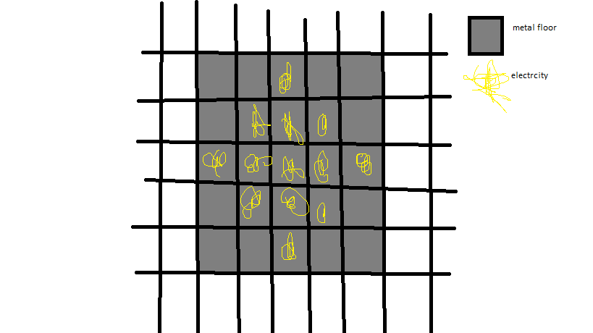

The last game play mechanic is evolution/ fusion your units can merge with each other and evolve into new forms.

Requirements:

* Both units need to level
* Player needs to have an evolution stone

The first upside to evolution is that 75% of their base stats (the stats they have at level one) are added together, if it is a decimal it is rounded to the nearest one. Rounded up if it’s .5.

Example

Slime spider = slime-spider

Base

Atk 3 9 | 2+7 = 9

Def 6 4 | 5+3 = 8

Spd 2 7 | 2+5 = 7

Skill 2 3 | 2+2 = 4

As you can see the spider slime has superior stats than both the slime or the spider.

Also, their modifiers (the percentages used to see what stats increase when units level up) are chosen randomly than between the two than passed on to the fused monster.

so when a monster levels up say they have an attack mod of 65% that means the unit has a 65% chance of increasing their attack upon leveling up.

Example

Slime spider = slime-spider

Base

Atk 65% 50% | = 65%

Def 80% 45% | = 80%

Spd 40% 90% | = 40%

Skill 20% 50% | = 20%

As you can see it’s a fifty fifty throw up chance on what modifiers the fusion will receive from their “parents” when fused.

On the note of skills the fused unit will have access to skills that their “parent” units would have though it would still need to be at the required level to unlock that skill, ex the skill slime body is unlocked at level 4 and the skill spider climb is unlocked at level 14.

Lastly The level cap of the fused monster will be the highest level cap between the two monsters plus 10, so the if the slimes max level is 15 and the spiders is 20, the highest level between the two is the spiders level 20 so the slime-spiders max level is 30. The spiders max level of 20 + 10.

Downsides to fusions:

* The fused unit will be reset to level one.
* You are essentially losing a unit, using two units to get one
* The fusion can possibly get mod screwed

Upsides to fusion:

* The fused unit will have higher base stats than their ”parent” monsters
* They have access to the skills of both their “parent” monsters
* Can possibly be have broken modifiers.

So, to go over some questions that maybe posed.

Q) slimes have low base stats, so why would I just not use higher grade monsters like a spider and a golem?

A) slimes may have low base stats, but they also have the lowest level cap meaning they can be used for fusion early than most.

Q) is there any way to tell what a monster mods are before fusing them?

A)yes their will be a fortune teller available between levels that will tell you what a monsters mods are.

For Example the fortune teller might say the following:

81 - 100%

“this monster is most gifted when it comes to \*insert stat here\*”

61 - 80%

“this monster excels at \*insert stat here\*”

41 - 60%

“This monster is average at \*insert stat here\*”

21 - 40%

“this monster is less than average at \*insert stat here\*”

0 - 20%

“this monster is horrible at \*insert stat here\*”

How monster stats work.

When a recruit able monster is spawned on the map its base stats can be up to 2 higher or 2 lower than their given average.

their modifiers are randomized between 10% to 100% this is so people don’t get mod screwed if their monster have all stat mod at 0%